|  |  |  |  |  |  |  |
| --- | --- | --- | --- | --- | --- | --- |
| **Account**  **Number**  **Test** | **Step** | **Event/ Entry** | **Transaction**  **Amount** | **Output** | **Message** | **Status**  **Pass/Fail** |
| ***Test Case 1*** | | | | | | |
| 6323 | 1 | User Entry | 6323 |  | at ***Enter Account # (four digits)*** prompt |  |
|  | 2 | Request Balance |  | 20000 | at ***Current Balance*** prompt |  |
|  | 3 | User Entry | 500 |  | at ***Transaction Amount*** prompt |  |
|  | 4 | Increase |  | 20500 | **The new Balance for Account 6323 is 20500** | Pass |
|  | 5 | User Entry | 1000 |  | at ***Transaction Amount*** prompt |  |
|  | 6 | Decrease |  | 19500 | **The new Balance for Account 6323 is 19500** | Pass |
|  | 7 | User Entry | 0 |  | at ***Transaction Amount*** prompt |  |
|  | 8 | Decrease |  | 19500 | **The new Balance for Account 6323 is 19500** | Pass |
|  | 9 | User Entry | 5000 |  | at ***Transaction Amount*** prompt |  |
|  | 10 | Increase |  | 24500 | **The new Balance for Account 6323 is 24500** | Pass |
|  | 11 | User Entry | -99 |  | at ***Transaction Amount*** prompt |  |
|  | 12 | Decrease |  | 24599 | **The new Balance for Account 6323 is 24599** | Pass |
|  | 13 | User Entry | 150 |  | at ***Transaction Amount*** prompt |  |
|  | 14 | Increase |  | 24749 | **The new Balance for Account 6323 is 24749** | Pass |
|  | 15 | Click Close X |  |  | **[Ends program.]** |  |

|  |  |  |  |  |  |  |
| --- | --- | --- | --- | --- | --- | --- |
| **Account**  **Number**  **Test** | **Step** | **Event/ Entry** | **Transaction**  **Amount** | **Output** | **Message** | **Status**  **Pass/Fail** |
| ***Test Case 2*** | | | | | | |
| 8921 | 1 | User Entry | 8921 |  | at ***Enter Account # (four digits)*** prompt |  |
|  | 2 | Request Balance |  | 2500 | at ***Current Balance*** prompt |  |
|  | 3 | User Entry | 150 |  | at ***Transaction Amount*** prompt |  |
|  | 4 | Decrease |  | 2350 | **The new Balance for Account 8921 is 2350** | Pass |
|  | 5 | User Entry | 1000 |  | at ***Transaction Amount*** prompt |  |
|  | 6 | Increase |  | 3350 | **The new Balance for Account 8921 is 3350** | Pass |
|  | 7 | User Entry | 600 |  | at ***Transaction Amount*** prompt |  |
|  | 8 | Decrease |  | 2750 | **The new Balance for Account 8921 is 2750** | Pass |
|  | 9 | User Entry | 35 |  | at ***Transaction Amount*** prompt |  |
|  | 10 | Increase |  | 2785 | **The new Balance for Account 8921 is 2785** | Pass |
|  | 11 | User Entry | 249 |  | at ***Transaction Amount*** prompt |  |
|  | 12 | Decrease |  | 2536 | **The new Balance for Account 8921 is 2536** | Pass |
|  | 13 | User Entry | 372 |  | at ***Transaction Amount*** prompt |  |
|  | 14 | Increase |  | 2908 | **The new Balance for Account 8921 is 2908** | Pass |
|  | 15 | Click Close X |  |  | **[Ends program.]** |  |

|  |  |  |  |  |  |  |
| --- | --- | --- | --- | --- | --- | --- |
| **Account**  **Number**  **Test** | **Step** | **Event/ Entry** | **Transaction**  **Amount** | **Output** | **Message** | **Status**  **Pass/Fail** |
| ***Test Case 3*** | | | | | | |
| 3523 | 1 | User Entry | 3523 |  | at ***Enter Account # (four digits)*** prompt |  |
|  | 2 | Request Balance |  | 320 | at ***Current Balance*** prompt |  |
|  | 3 | User Entry | 500 |  | at ***Transaction Amount*** prompt |  |
|  | 4 | Increase |  | 820 | **The new Balance for Account 3523 is 820** | Pass |
|  | 5 | User Entry | 50 |  | at ***Transaction Amount*** prompt |  |
|  | 6 | Decrease |  | 770 | **The new Balance for Account 3523 is 770** | Pass |
| 9999 | 7 | User Entry | 9999 |  | at ***Enter Account # (four digits)*** prompt |  |
|  | 8 | Request Balance |  | 0 | at ***Current Balance*** prompt |  |
|  |  |  |  |  | **Account number does not exist. Please try again.** | Pass |
| 1023 | 9 | User Entry | 1023 |  | at ***Enter Account # (four digits)*** prompt |  |
|  | 10 | Request Balance |  | 3000 | at ***Current Balance*** prompt | Pass |
|  | 11 | User Entry | 525 |  | at ***Transaction Amount*** prompt |  |
|  | 12 | Decrease |  | 2475 | **The new Balance for Account 1023 is 2475** | Pass |
|  | 13 | User Entry | 199 |  | at ***Transaction Amount*** prompt |  |
|  | 14 | Increase |  | 2674 | **The new Balance for Account 1023 is 2674** | Pass |
| 9242 | 15 | User Entry | 9242 |  | at ***Enter Account # (four digits)*** prompt |  |
|  | 16 | Request Balance |  | 400 | at ***Current Balance*** prompt | Pass |
|  | 17 | User Entry | 175 |  | at ***Transaction Amount*** prompt |  |
|  | 18 | Increase |  | 575 | **The new Balance for Account 9242 is 575** | Pass |
|  | 19 | User Entry | 43 |  | at ***Transaction Amount*** prompt |  |
|  | 20 | Increase |  | 532 | **The new Balance for Account 9242 is 532** | Pass |
| 1111 | 21 | User Entry | 1111 |  | at ***Enter Account # (four digits)*** prompt |  |
|  | 22 | Request Balance |  | 0 | at ***Current Balance*** prompt |  |
|  |  |  |  |  | **Account number does not exist. Please try again.** | Pass |
| 3523 | 23 | User Entry | 3523 |  | at ***Enter Account # (four digits)*** prompt |  |
|  | 24 | Request Balance |  | 770 | at ***Current Balance*** prompt | Pass |
| 1023 | 25 | User Entry | 1023 |  | at ***Enter Account # (four digits)*** prompt |  |
|  | 26 | Request Balance |  | 2674 | at ***Current Balance*** prompt | Pass |
| 9242 | 27 | User Entry | 9242 |  | at ***Enter Account # (four digits)*** prompt |  |
|  | 28 | Request Balance |  | 532 | at ***Current Balance*** prompt | Pass |
|  | 29 | Click Close X |  |  | **[Ends program.]** |  |

Test Case 1 Screen Capture Final Window:

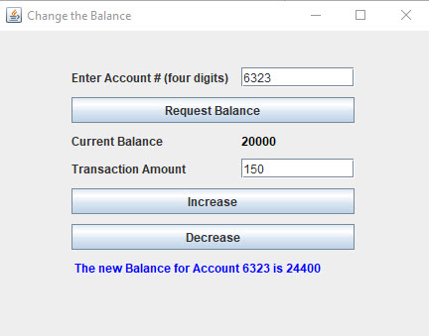

Test Case 2 Screen Capture Final Window:

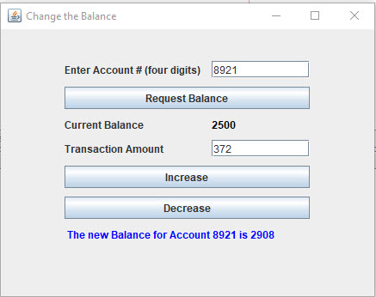

Test Case 3 Screen Capture Final Window:

